INDEED.COM “POST A JOB”
GENERAL INFORMATION
Job Title:
Tour Staff Photographer

Job Location:
In-Person, Exact Location (show on job description):
AT&T way, Arlington, TX. 76010

JOB DESCRIPTION
Job Type:
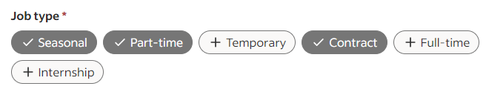
Pay:
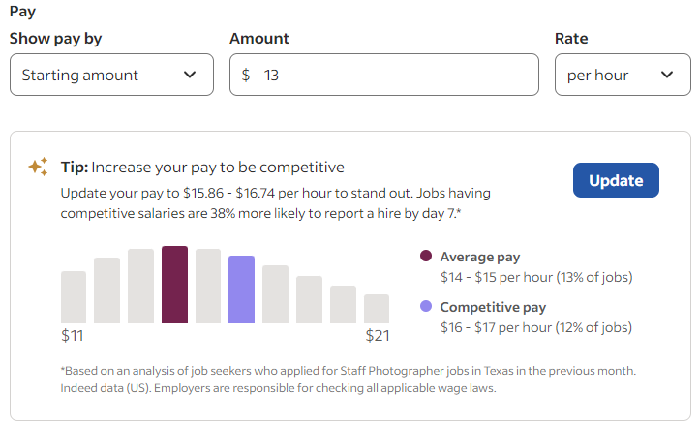
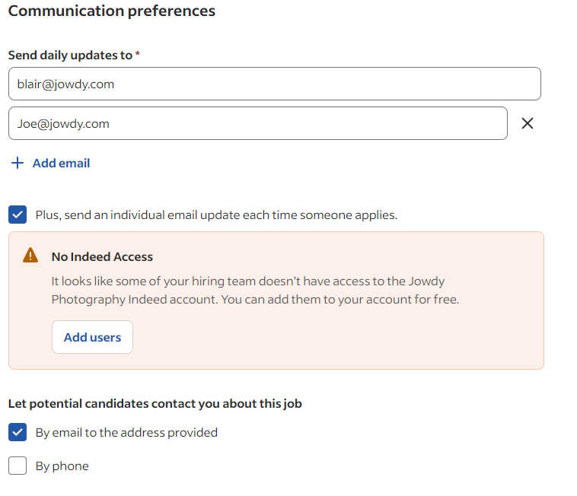

JOB DESCRIPTION
Looking for High Energy and Outgoing People to work at AT&T Stadium, Home of the Dallas Cowboys. For over 35 years Jowdy Photography has provided a wide range of photography services to our clients all over the country. We are the Official Photography Company of the Dallas Cowboys.
Job Overview:
We are currently looking to hire a Staff Photographer to join our AT&T Stadium Tours team! Being a member of Jowdy tour staff involves approaching and engaging stadium guests; encouraging them to participate in various photo opportunities; and finally, to purchase official souvenir photographs; all as part of the ‘AT&T Stadium Tour’ guest experience. Work with a team to capture, process, print and sell photographs, as well as have fun making it memorable for guests.
Staff Photographer Specific Duties:
- Capture high-quality images of tour guests.
- Ensure images align with our brand and meet the needs of various products we offer.
- Responsible that all images are delivered on time and meet quality standards.
- Perform daily setup and breakdown of photo-op equipment.
- Maintain photography equipment to keep it in good working condition.
Qualifications:
- You must possess a friendly, outgoing, and positive attitude.
- Ability to perform both independently as well as actively contribute to a team setting.
- Strong communication skills to effectively interact with guests, clients, and team members.
- Leadership qualities to guide photo shoots and direct subjects as needed.
- Customer service orientation to ensure client satisfaction.
- Willingness to learn new photography, computer, networking, and POS skills and educate others on techniques and best practices.
Job Requirements:
- Must be a valid US Citizen & can work in the US (Social Security Card verification is required)
- Uniform attire: Black polo shirt, black work pants (NOT jeans or leggings) & Black closed shoes.
- Bilingual or multilingual proficiency is a plus
This position offers the opportunity to work in a creative environment, develop photography skills, and could lead to greater responsibilities in photography or management. If you are passionate about photography and possess the required qualifications, we would love to hear from you.

